Kathmandu University
Department of Artificial Intelligence
Dhulikhel, Kavre



Lab Report-V
A Comparative Study of CPU and GPU Performance for Training a Cats vs Dogs Classification Model

Subject Code: AICL 318
Cloud Computing and AI
BTech in Artificial Intelligence

Submitted by,
Ashish Gupta
Batch 2023

Submitted to,
Rupak Gyawali
Department of Artificial Intelligence

A Comparative Study of CPU and GPU Performance for Training a Cats vs Dogs Classification Model

Step 1:



Step 2:

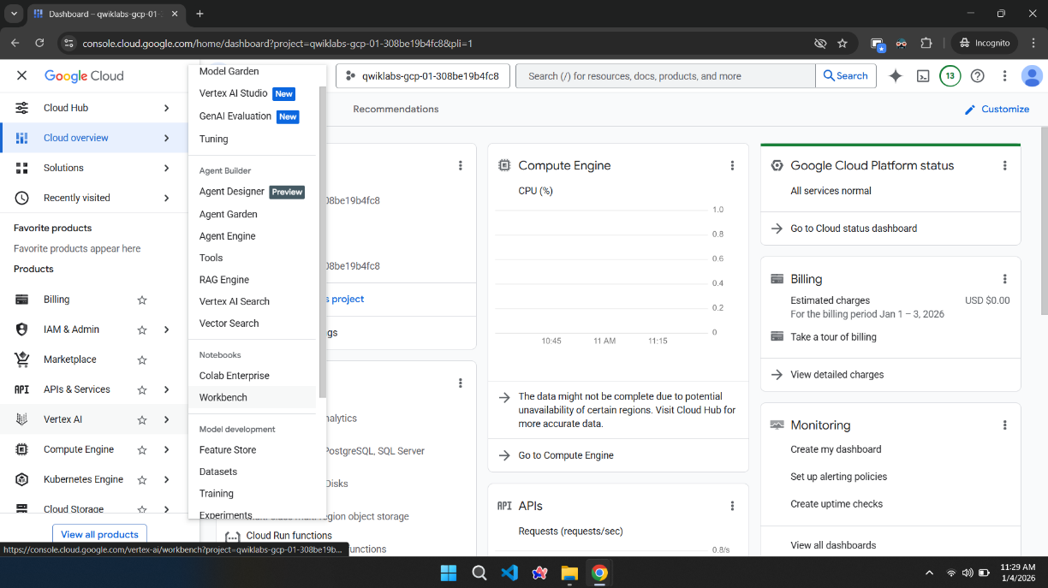

Step 3:

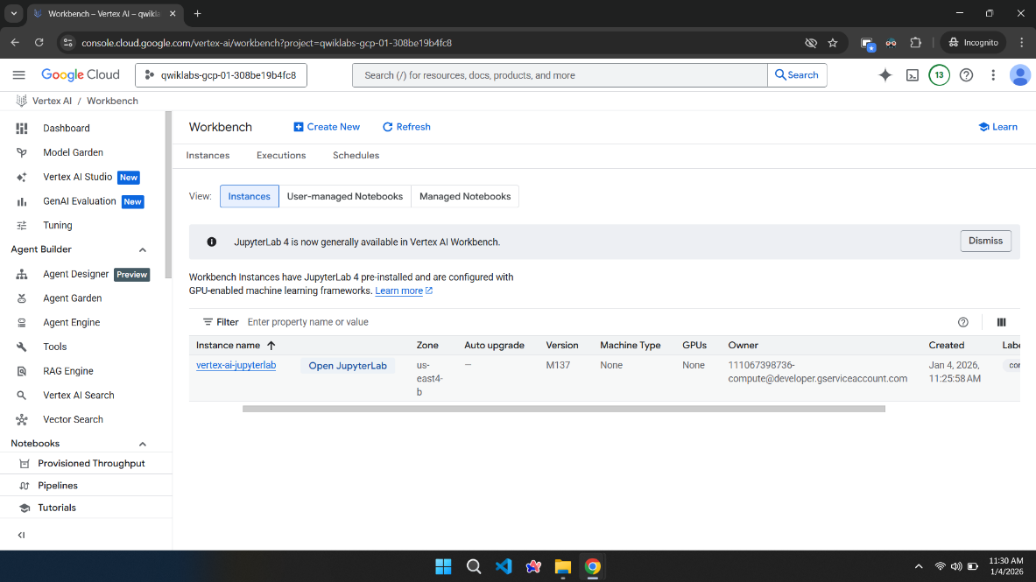

Step 4:

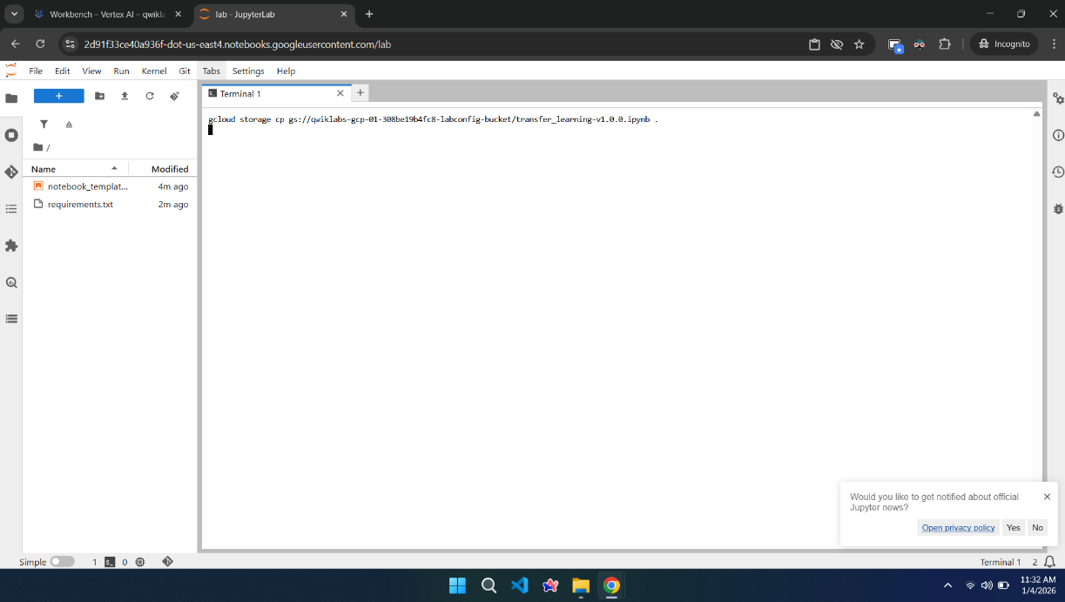
Step 5:

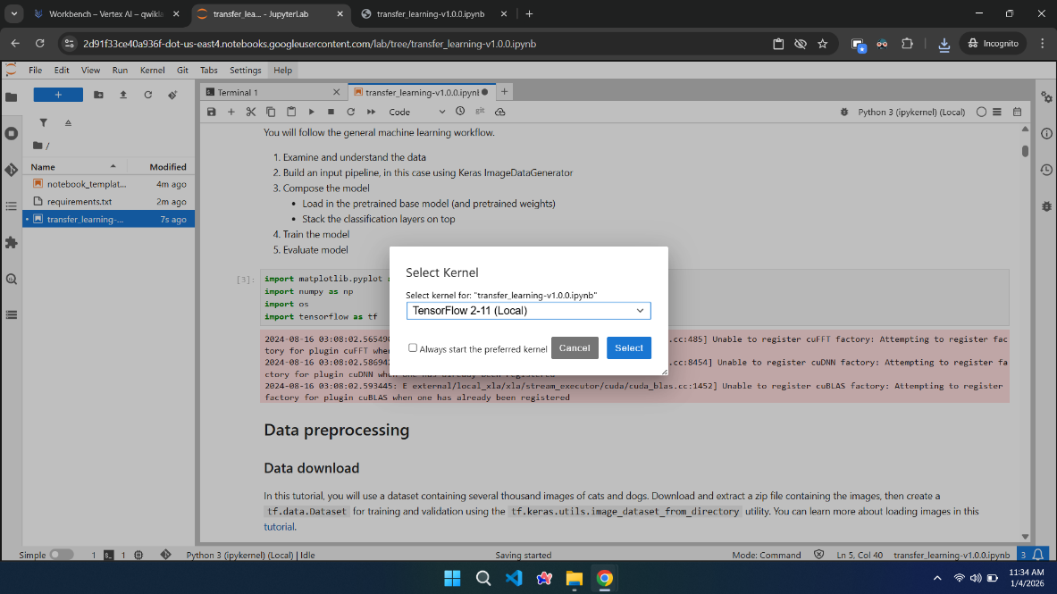
+

Step 6:

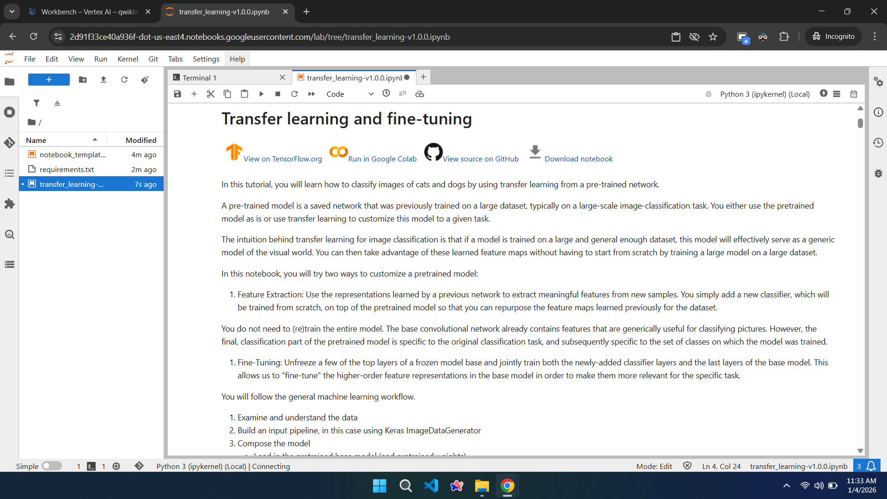

Step 7:

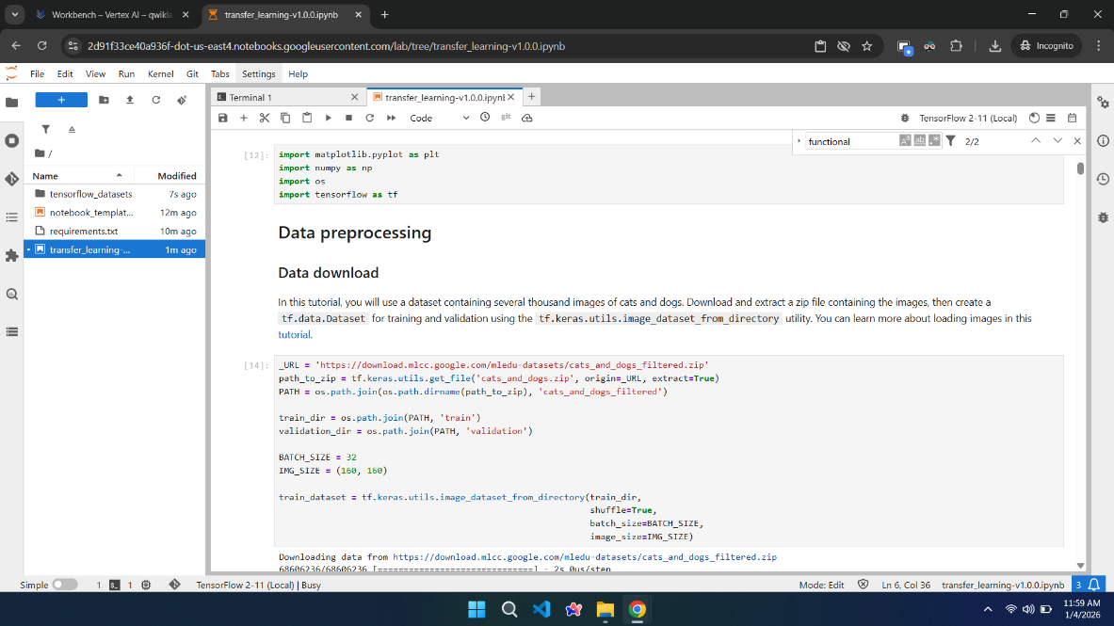

Step 8:

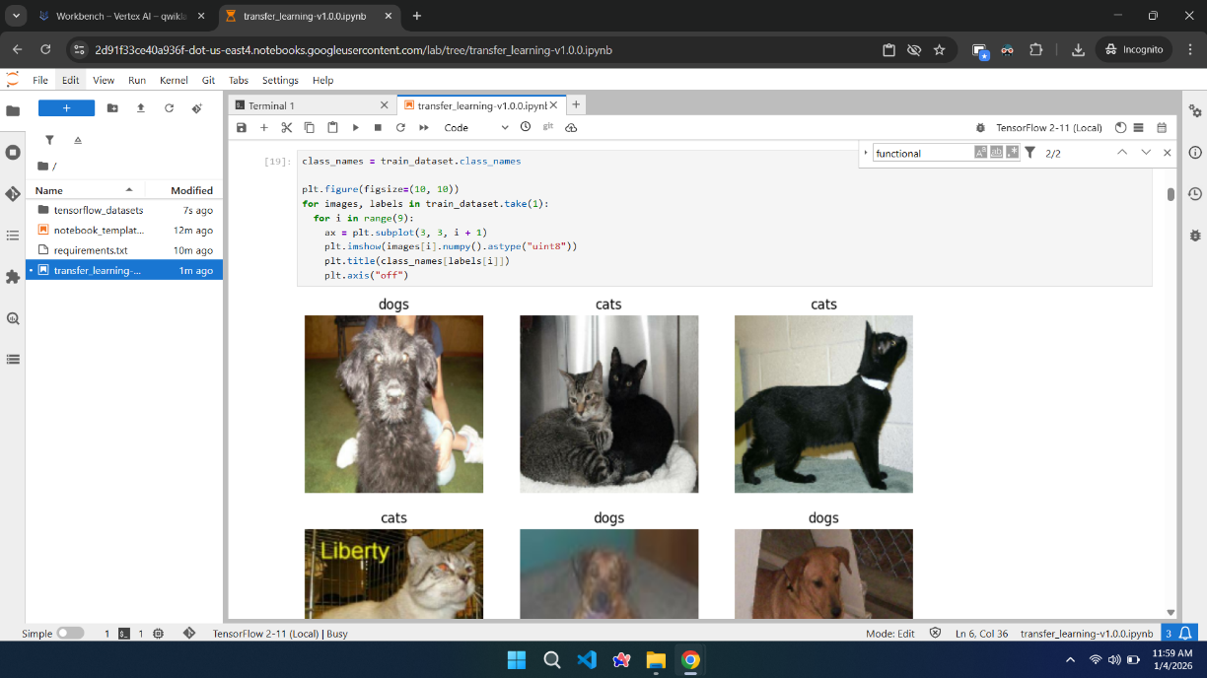

Step 9:

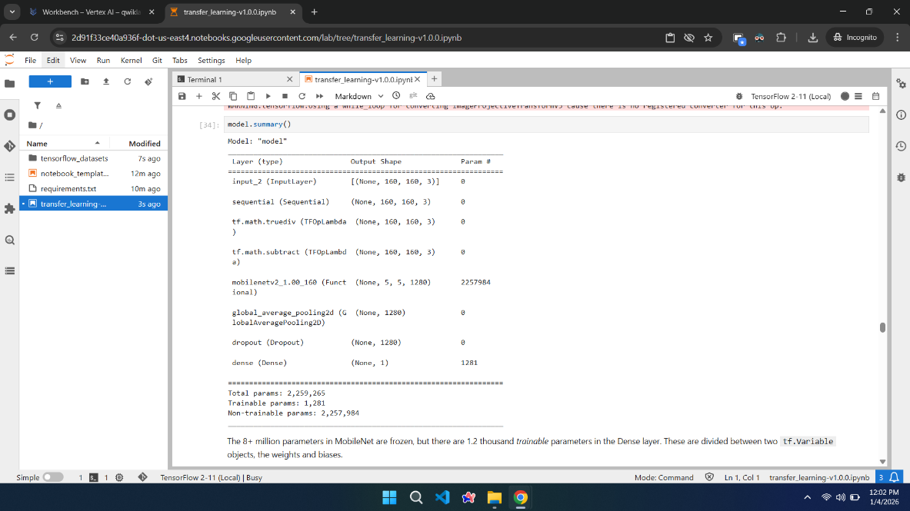

Step 10:

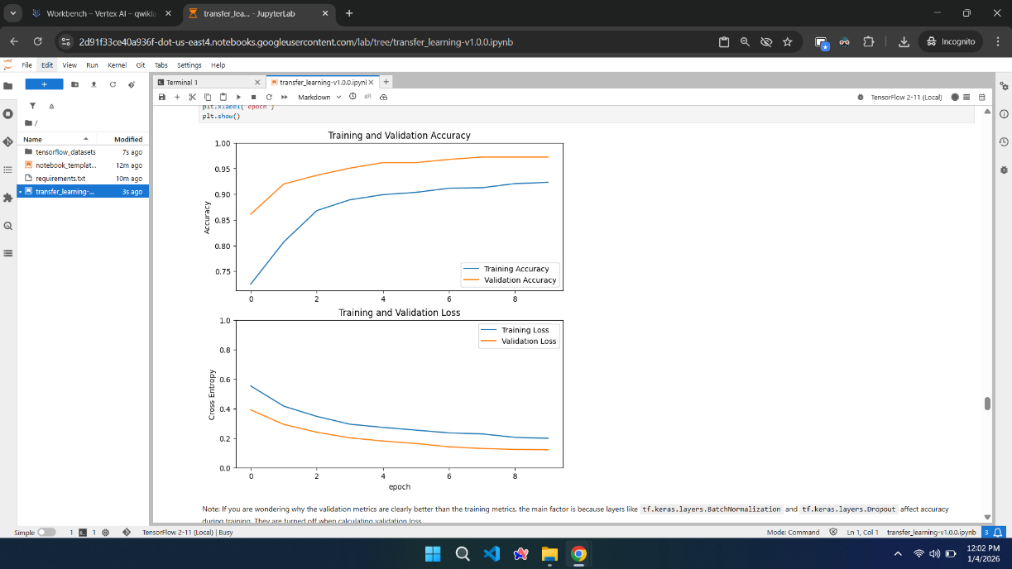
Step 11:

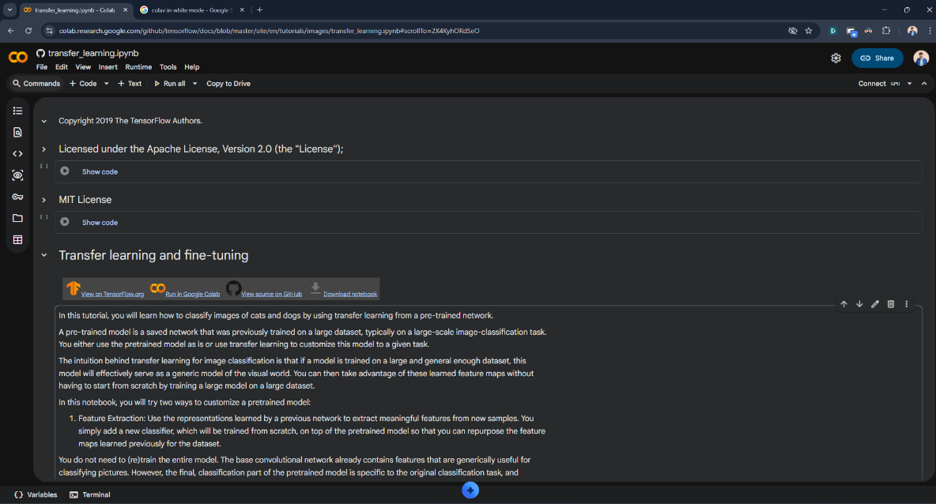

Step 12:

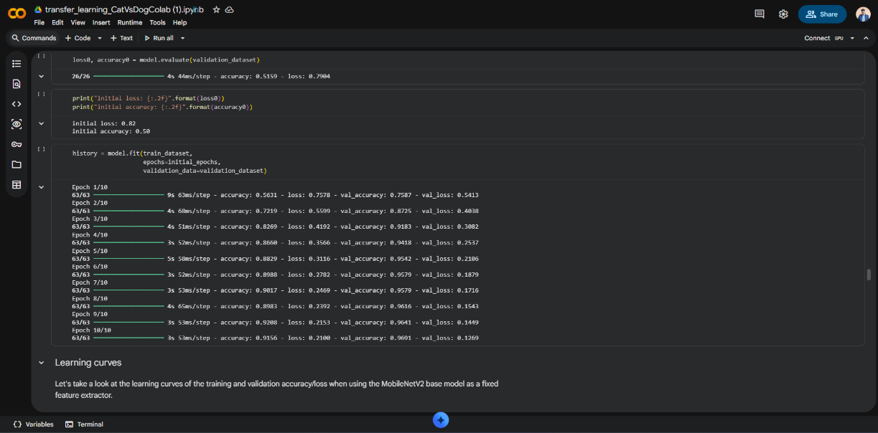

Step 13:

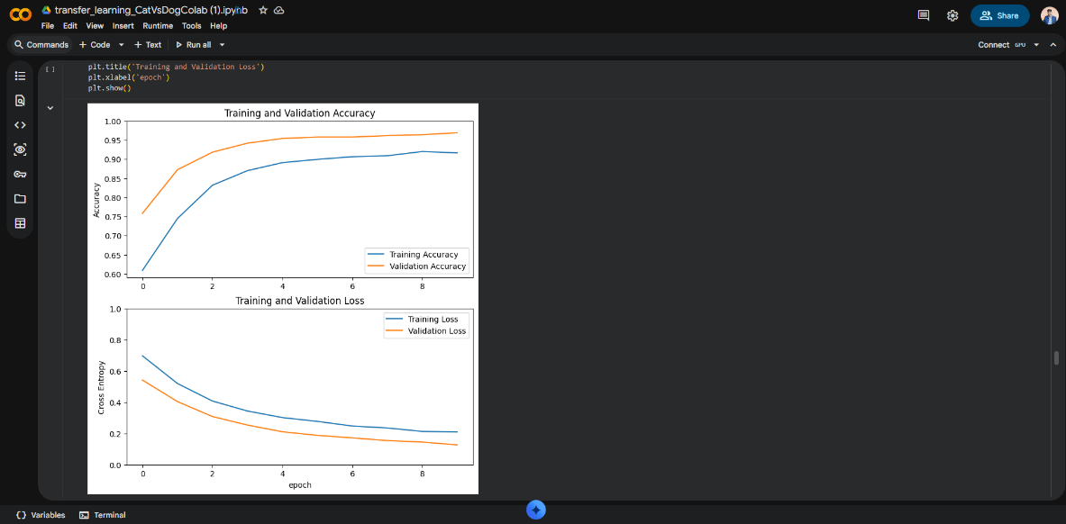

Step 14:

